
BLO2010 – Distribution Centre Management
(AY2025/2026 Apr)

Group Project Report

Submitted By

Group Number _____
Class : ______

Name of Student | Signature
Chen Zehua
PON JIN XUAN | 

Declaration of Originality

I am the originator of this work and I have appropriately acknowledged all other original sources used as my reference for this work.
I understand that Plagiarism is the act of taking and using the whole or any part of another person’s work, including work generated by AI, and presenting it as my own.
I understand that Plagiarism is an academic offence
and if I am found to have committed or abetted the offence of plagiarism in relation to this submitted work, disciplinary action will be enforced.

Declaration on the use of Generative AI tools for assignments

Describe how you have used Generative AI tools such as ChatGPT or Dall.E-2 in your assignment.

Show snapshots of the conversations with the AI tool (i.e., the prompts you used and the response you get from the AI tool).

How to indicate the reference?
The content generated by AI tools are not retrievable except by the user who generated them, so they are considered non-recoverable sources. For non-recoverable sources:
- do not include in a reference list
- cite within the text as personal communications or correspondence
Based on APA 7th edition referencing format,
(Communicator, personal communication, Month Day, year)

E.g. (Paraphrase from OpenAI's ChatGPT AI language model, personal communication, March 8­, 2023).

Important Note:

- Do not copy answers produced by the AI tool in totality as it is considered as plagiarism.

- Do not rely on any information produced by the AI tool blindly. You should always verify the answer with other sources. Do not assume that these answers provided by the AI tool are correct.

- To achieve quality outputs from the AI tool, you should provide good prompt that is clear and specific. Be precise and provide context. Avoid asking open-ended questions.

Table Of Contents
Table Of Contents 3
A. To achieve a 95% daily service level, we analyzed TRAVEL PAL’s historical volume data using Microsoft Excel 4
B. Resources Planning 5
Inbound Activity (Daily Volume) 6
Inbound Activity (High Volume) 9
Inbound Activity (Low Volume) 13
Outbound Activity (Daily Volume) 17
Outbound Activity (High Volume) 21
Outbound Activity (Low Volume) 25
C. Pricing 29
Inbound (Daily Volume) 30
Inbound (High Volume) 30
Inbound (Low Volume) 30
Outbound (Daily Volume) 30
Outbound (High Volume) 31
Outbound (Low Volume) 31
Storage (Daily Volume) 31
Storage (High Volume) 32
Storage (Low Volume) 32
D. The following is the proposed sketch for the DC Layout 32
E. Derived Requirements 34
Area of Working Space and Staging Space (for both Outbound andInbound) 37
Estimated total DC space area 40
F. Pallet-In-Pallet-Out operation 41

A. To achieve a 95% daily service level, we analyzed TRAVEL PAL’s historical volume data using Microsoft Excel
We used the 95th percentile of inbound, outbound and balance values to determine what volume achieves 95% success rate annually.
The 95th percentile value of inbound, outbound and balance for that year shows what values fulfill 95 percent of the days. For example, there are 100 days. The value that fulfills 95 days is the 95th percentile value. 95th percentile means the value that is higher than 95 percent than rest of the data.
Operation | 95th percentile value
IN | 1920
OUT | 1480
BAL | 2802.5

Data From This Excel Sheet

B. Resources Planning

Inbound Activity (Daily Volume)
Number of inbound cartons = 1560
Number of pallets = 1560 ÷ 12 = 130 (12 cartons in one pallet)
Number of backpacks = 1560 × 6 = 9360 (1 carton contains 6 pieces)
Number of Pallets (Forecasted growth) = 130 × (1+0.1)⁵ = 209.37 ≈ 210 pallets
Number of Cartons (Forecasted Growth) = 1560 × (1+0.1)⁵ = 2512.4 ≈ 2513
Number of pieces (forecasted growth) = 9630 × (1+0.1)⁵ = 15074.4 ≈ 15075
Number of working hours = 1800hr – 0830hr -1hr = 8.5 hours
Manual
Inbound ACTIVITY (Manual)
Task | UOM Per Task | Daily Volume per task | No. of working hours per shift | Standard Time (UOM per hour) | Estimated No. of Workers Required
Unload Full Pallets from container | Pallet | 210 | 8.5 | 45 | 0.55
Move UOM to Inbound Working Area | Pallet | 210 | 8.5 | 100 | 0.25
Inspect Pallet and sign POD | Pallet | 210 | 8.5 | 120 | 0.21
Enter Cargo receiving data for pallet | Pallet | 210 | 8.5 | 200 | 0.12
Break Shipping Cartons from pallet | Carton | 2513 | 8.5 | 180 | 1.64
break Piece from shipping Carton | Piece | 15075 | 8.5 | 300 | 5.91
Pasting of Licence Plate Number | Piece | 15075 | 8.5 | 360 | 4.93
Move to Inbound Staging Area | Piece | 15075 | 8.5 | 100 | 17.74
Putaway Piece | Piece | 15075 | 8.5 | 180 | 9.85
Total Workers |  |  |  |  | 41.19 ≈ 42
Supervisor |  |  |  |  | 5

Automation

Since TP prefers automation, the automation manpower grid is used to decide the number of handlers and supervisors to be hired. The labour cost will be calculated based on that.
Number of shifts per day
There will be 3 shifts per day:
Shift 1: 8.30 am – 2.30 pm (6 hrs) | Shift 2: 10.30 am – 4.30 pm (6 hrs) | Shift 3: 12 pm – 6 pm (6 hrs)

Inbound ACTIVITY (Automation)
Task | UOM Per Task | Daily Volume per task | No. of working hours per shift | Standard Time (UOM per hour) | Estimated No. of Workers Required
Unload Full Pallets from container | Pallet | 210 | 8.5 | 45 | 0.55
Move UOM to Inbound Working Area | Pallet | 210 | 8.5 | 100 | 0.25
Inspect Pallet and sign POD | Pallet | 210 | 8.5 | 120 | 0.21
Enter Cargo receiving data for pallet | Pallet | 210 | 8.5 | 500 | 0.05
Break Shipping Cartons from pallet | Carton | 2513 | 8.5 | 180 | 1.64
break Piece from shipping Carton | Piece | 15074.3736 | 8.5 | 300 | 5.91
Pasting of Licence Plate Number | Piece | 15074.3736 | 8.5 | 360 | 4.93
Move to Inbound Staging Area | Piece | 15074.3736 | 8.5 | 600 | 2.96
Putaway Pieces into AutoStore | Piece | 15074.3736 | 8.5 | 250 | 7.09
Total Workers |  |  |  |  | 23.58 ≈ 24
Supervisor |  |  |  |  | 3

6-hour shifts are implemented to avoid OT during normal volumes. If workers are required to OT during normal volumes, more staff will be needed for high volumes, which will cause the labour cost to be much higher.
The roster for the shifts will look like:
Worker Group | Mon | Tue | Wed | Thu | Fri | Sat | Sun
Group A (8) 8.30 - 2.30 pm | Work | Work | Work | Work | Work | Work | Rest
Group B (8) 10.30 am - 4.30 pm | Work | Work | Work | Work | Work | Work | Rest
Group 3 (8) 12 pm - 6 pm | Work | Work | Work | work | Work | Work | Rest

The roster below shows each shift for each supervisor.
Supervisor | Mon | Tue | Wed | Thu | Fri | Sat | Sun
Sup 1 (8.30am - 2.30pm) | Work | Work | Work | Work | Work | Work | OFF
Sup 2 (10.30am – 4.30pm) | Work | Work | Work | Work | Work | Work | OFF
Sup 3 (12pm - 6pm) | Work | Work | Work | Work | Work | Work | OFF

Labour Cost
Fully-Loaded Cost per Handler = 2000 × 1.6 = 3200
Total Handler Cost – Inbound = 3200 × 24 = 76800
Expected number of Supervisors = 2
Fully-Loaded Cost per Supervisor = 2800 × 1.6 = 4480
Total Supervisor Cost – Inbound = 4480 × 3 = 13440
Total Labour Cost – Inbound =13440 + 76800 = 90240

Inbound Activity (High Volume)
Number of inbound cartons = 1920
Number of pallets = 1920 ÷ 12 = 160 (12 cartons in one pallet)
Number of backpacks = 1920 × 6 = 11520 (1 carton contains 6 pieces)
Number of Pallets (Forecasted growth) = 160 × (1+0.1)⁵ = 257.682 ≈ 258 pallets
Number of Cartons (Forecasted Growth) = 1920 × (1+0.1)⁵ = 3092.18 ≈ 3093
Number of pieces (forecasted growth) = 11520 × (1+0.1)⁵ = 18553.1 ≈ 18554
Number of working hours = 1800hr – 0830hr -1hr =8.5
Manual
Inbound ACTIVITY (Manual)
Task | UOM Per Task | Daily Volume per task | No. of working hours per shift | Standard Time (UOM per hour) | Estimated No. of Workers Required
Unload Full Pallets from container | Pallet | 258 | 8.5 | 45 | 0.67
Move UOM to Inbound Working Area | Pallet | 258 | 8.5 | 100 | 0.30
Inspect Pallet and sign POD | Pallet | 258 | 8.5 | 120 | 0.25
Enter Cargo receiving data for pallet | Pallet | 258 | 8.5 | 200 | 0.15
Break Shipping Cartons from pallet | Carton | 3093 | 8.5 | 180 | 2.02
break Piece from shipping Carton | Piece | 18554 | 8.5 | 300 | 7.28
Pasting of Licence Plate Number | Piece | 18554 | 8.5 | 360 | 6.06
Move to Inbound Staging Area | Piece | 18554 | 8.5 | 100 | 21.83
Putaway Piece | Piece | 18554 | 8.5 | 180 | 12.13
Total Workers |  |  |  |  | 50.70 ≈ 51
Supervisor |  |  |  |  | 6

Automation
Inbound ACTIVITY (Automation)
Task | UOM Per Task | Daily Volume per task | No. of working hours per shift | Standard Time (UOM per hour) | Estimated No. of Workers Required
Unload Full Pallets from container | Pallet | 258 | 8.5 | 45 | 0.67
Move UOM to Inbound Working Area | Pallet | 258 | 8.5 | 100 | 0.30
Inspect Pallet and sign POD | Pallet | 258 | 8.5 | 120 | 0.25
Enter Cargo receiving data for pallet | Pallet | 258 | 8.5 | 500 | 0.06
Break Shipping Cartons from pallet | Carton | 3093 | 8.5 | 180 | 2.02
break Piece from shipping Carton | Piece | 18554 | 8.5 | 300 | 7.28
Pasting of Licence Plate Number | Piece | 18554 | 8.5 | 360 | 6.06
Move to Inbound Staging Area | Piece | 18554 | 8.5 | 600 | 3.64
Putaway Pieces into AutoStore | Piece | 18554 | 8.5 | 250 | 8.73
Total Workers |  |  |  |  | 29.02 ≈ 30
Supervisor |  |  |  |  | 3

During high volumes, workers are to work 8 hours per day. In addition, 5 part time staffs are to be hired. The number of shifts remain as 3.
Number of OT hours = (8 × 6) – 44 = 4 hours
Fully-Loaded Cost per Handler = 2000 × 1.6 = 3200
Monthly OT Cost per Handler = (2000 × 12) ÷ (52 × 44) × 1.5 × 1.17 × (4 hours per week × 4 weeks) = 294.55
Total Handler Cost – Inbound = (3200 + 294.55) × 24 = 83869.20
Expected number of Supervisors = 3
Fully-Loaded Cost per Supervisor = 2800 × 1.6 = 4480
Monthly OT Cost per Supervisor = (2800 × 12) ÷ (52 × 44) × 1.5 × 1.17 × (4 hours per week × 4 weeks) = 412.36
Total Supervisor Cost – Inbound = (4480 + 412.36) × 3 = 14677.08
Total Temporary Staff Cost – Inbound = 15 × 6hrs × 5 staff = 450
Total Labour Cost – Inbound = 83869.20 + 14677.08 + 450 = 98996.28
The roster for the shifts will look like:
Worker Group | Mon | Tue | Wed | Thu | Fri | Sat | Sun
Group A (6) 8.30 - 4.30 pm | Work | Work | Work | Work | Work | Work | Rest
Group B (6) 9.30 am - 5.30 pm | Work | Work | Work | Work | Work | Work | Rest
Group 3 (6) 10 am - 6 pm | Work | Work | Work | work | Work | Work | Rest
Part timers (5) 12 pm – 6 pm | Work | Work | Work | Work | Work | Work | Rest

The roster below shows each shift for each supervisor.
Supervisor | Mon | Tue | Wed | Thu | Fri | Sat | Sun
Sup 1 (8.30am - 4.30pm) | Work | Work | Work | Work | Work | Work | OFF
Sup 2 (9.30am – 5.30pm) | Work | Work | Work | Work | Work | Work | OFF
Sup 3 (10pm - 6pm) | Work | Work | Work | Work | Work | Work | OFF

Inbound Activity (Low Volume)
Number of inbound cartons = 240
Number of pallets = 240 ÷ 12 = 20 (12 cartons in one pallet)
Number of backpacks = 240 × 6 = 1440 (1 carton contains 6 pieces)
Number of Pallets (Forecasted growth) = 20 × (1+0.1)⁵ = 32.21 ≈ 33 pallets
Number of Cartons (Forecasted Growth) = 240 × (1+0.1)⁵ = 386.52 ≈ 387
Number of pieces (forecasted growth) = 1440 × (1+0.1)⁵ = 2319.13 ≈ 2320
Number of working hours = 1800hr – 0830hr -1hr =8.5
Inbound ACTIVITY (Manual)
Task | UOM Per Task | Daily Volume per task | No. of working hours per shift | Standard Time (UOM per hour) | Estimated No. of Workers Required
Unload Full Pallets from container | Pallet | 33 | 8.5 | 45 | 0.09
Move UOM to Inbound Working Area | Pallet | 33 | 8.5 | 100 | 0.04
Inspect Pallet and sign POD | Pallet | 33 | 8.5 | 120 | 0.03
Enter Cargo receiving data for pallet | Pallet | 33 | 8.5 | 200 | 0.02
Break Shipping Cartons from pallet | Carton | 387 | 8.5 | 180 | 0.25
break Piece from shipping Carton | Piece | 2320 | 8.5 | 300 | 0.91
Pasting of Licence Plate Number | Piece | 2320 | 8.5 | 360 | 0.76
Move to Inbound Staging Area | Piece | 2320 | 8.5 | 100 | 2.73
Putaway Piece | Piece | 2320 | 8.5 | 180 | 1.52
Total Workers |  |  |  |  | 6.34 ≈ 7
Supervisor |  |  |  |  | 1

Automation
Inbound ACTIVITY (Automation)
Task | UOM Per Task | Daily Volume per task | No. of working hours per shift | Standard Time (UOM per hour) | Estimated No. of Workers Required
Unload Full Pallets from container | Pallet | 33 | 8.5 | 45 | 0.09
Move UOM to Inbound Working Area | Pallet | 33 | 8.5 | 100 | 0.04
Inspect Pallet and sign POD | Pallet | 33 | 8.5 | 120 | 0.03
Enter Cargo receiving data for pallet | Pallet | 33 | 8.5 | 500 | 0.01
Break Shipping Cartons from pallet | Carton | 387 | 8.5 | 180 | 0.25
break Piece from shipping Carton | Piece | 2320 | 8.5 | 300 | 0.91
Pasting of Licence Plate Number | Piece | 2320 | 8.5 | 360 | 0.76
Move to Inbound Staging Area | Piece | 2320 | 8.5 | 600 | 0.45
Putaway Pieces into AutoStore | Piece | 2320 | 8.5 | 250 | 1.09
Total Workers |  |  |  |  | 3.63 ≈ 4
Supervisor |  |  |  |  | 1

Handlers
During low volumes, there will not be shifts. 3 workers will work 8.5 hours for 3 days. There will only be 2 groups of workers, resulting in total of 6 workers for that week. There will only be one shift per day.
This is what the roster will look like:
Worker Group | Mon | Tue | Wed | Thu | Fri | Sat | Sun
Group A (4) 8.30 - 6 pm | Work | Work | Work | Rest | Rest | Rest | Rest
Group B (4) 8.30 - 6 pm | Rest | Rest | Rest | Work | Work | Work | Rest

Labour Cost (Handlers)
Fully-Loaded Cost per Handler = 2000 × 1.6 = 3200
Total Handler Cost – Inbound = 3200 × 8 = 25600
Supervisors
During low volumes, there will also not be shifts for supervisors. We will only need 2 supervisors to cover the 6 days. Each supervisor is required to work 8.5 hours for 3 days.
This is what the roster will look like.
Supervisor | Mon | Tue | Wed | Thu | Fri | Sat | Sun
Sup 1 (8.30am – 6pm) | Work | Work | Work | Rest | Rest | Rest | OFF
Sup 2 (8.30am - 6pm) | Rest | Rest | Rest | Work | Work | Work | OFF

Labour Cost (Supervisor)
Expected number of Supervisors = 2
Fully-Loaded Cost per Supervisor = 2800 × 1.6 = 4480
Total Supervisor Cost – Inbound = 4480 × 2 = 8960
Total Labour Cost
Total Labour Cost – Inbound = 8960 + 25600 = 34560

Outbound Activity (Daily Volume)
Number of inbound cartons = 1369 × 6 = 8122 (since the excel data provided is carton equivalent, ×6 because one carton has 6 pieces for inbound, while one carton has one piece for outbound)
Number of pieces = 8122
Number of shipping packages = 8122
Forecasted Growth = 8122 × (1+0.1)⁵ = 13223.9 ≈ 13224
Since outbound is supposed to operate for 24 hours for 7 days, split into 2 shifts (12 hours each)
Number of working hours = 12 – 1 = 11
Manual
Outbound ACTIVITY (Manual)
Task | UOM Per Task | Daily Volume per task | No. of working hours per shift | Standard Time (UOM per hour) | Estimated No. of Workers Required
Store Piece ; pick Piece | Piece | 13224 | 11 | 150 | 8.01
check piece | Piece | 13224 | 11 | 300 | 4.01
Update Location Information - Piece | Piece | 13224 | 11 | 200 | 6.01
Move to Outbound Working Area | Piece | 13224 | 11 | 100 | 12.02
check piece | Piece | 13224 | 11 | 300 | 4.01
piece - Packed into carton and labeling | Piece | 13224 | 11 | 80 | 15.03
carton - secure into shipping package and | Carton | 13224 | 11 | 80 | 15.03
enter cargo packing data for shipping package | Carton | 13224 | 11 | 200 | 6.01
move to outbound staging area | Carton | 13224 | 11 | 100 | 12.02
hand shipping package to freight forwarder | Carton | 13224 | 11 | 360 | 3.34
Total Workers |  |  |  |  | 85.49 ≈ 86
Supervisor |  |  |  |  | 9

Automation
Outbound ACTIVITY (Automation)
Task | UOM Per Task | Daily Volume per task | No. of working hours per shift | Standard Time (UOM per hour) | Estimated No. of Workers Required
pick piece from autostore | Piece | 13224 | 11 | 250 | 4.81
check piece | Piece | 13224 | 11 | 500 | 2.40
Update Location Information - Piece | Piece | 13224 | 11 | 500 | 2.40
Move to Outbound Working Area | Piece | 13224 | 11 | 500 | 2.40
check piece | Piece | 13224 | 11 | 600 | 2.00
piece - Packed into carton and labeling | Piece | 13224 | 11 | 80 | 15.03
carton - secure into shipping package and | Carton | 13224 | 11 | 80 | 15.03
enter cargo packing data for shipping package | Carton | 13224 | 11 | 400 | 3.01
move to outbound staging area | Carton | 13224 | 11 | 500 | 2.40
hand shipping package to freight forwarder | Carton | 13224 | 11 | 360 | 3.34
Total Workers |  |  |  |  | 52.83 ≈ 53
Supervisor |  |  |  |  | 6

Number of shifts per day (Daily Volume)
There will be 4 shifts per day:
Shift 1: 6.30 am – 6.30 pm | Shift 2: 6.30 pm – 6.30 am | Shift 3: 6.30 am – 6.30 pm | Shift 4: 6.30 pm – 6.30 am

The roster for the shifts will look like:
Worker Group | Mon | Tues | Wed | Thurs | Fri | Sat | Sun | Days Worked
1 (10) 6.30 am - 6.30pm | ✔ | ✔ | ✔ | ✔ | ❌ | ❌ | ❌ | 4
2(10) 6.30 am - 6.30pm | ❌ | ❌ | ❌ | ❌ | ✔ | ✔ | ✔ | 3
3(16) 6.30 pm - 6.30 am | ✔ | ✔ | ✔ | ✔ | ❌ | ❌ | ❌ | 4
4(17) 6.30 pm - 6.30 am | ❌ | ❌ | ❌ | ❌ | ✔ | ✔ | ✔ | 3

Supervisor | Mon | Tues | Wed | Thurs | Fri | Sat | Sun | Days Worked
Supp 1 (6.30 am - 6.30pm) | ✔ | ✔ | ✔ | ✔ | ❌ | ❌ | ❌ | 4
Supp 2 (6.30 am - 6.30pm) | ❌ | ❌ | ❌ | ❌ | ✔ | ✔ | ✔ | 3
Supp 3 and 4 (6.30 pm - 6.30 am) | ✔ | ✔ | ✔ | ✔ | ❌ | ❌ | ❌ | 4
Supp 5 and 6 (6.30 pm - 6.30 am) | ❌ | ❌ | ❌ | ❌ | ✔ | ✔ | ✔ | 3

Since its working hours per day is 12, adopt 4-3-3-4 arrangement.
Rotate every week | 4-3-3-4 | Also applies to supp
Week 1 | group 1 and 3 work 4 days, rest 3 days | group 2 and 4 work 3 days, rest 4 days
week 2 | group 1 and 3 work 3 days, rest 4 days | group 2 and 4 work 4 days, rest 3 days
week 3 | group 1 and 3 work 4 days, rest 3 days | group 2 and 4 work 3 days, rest 4 days
week 4 | group 1 and 3 work 3 days, rest 4 days | group 2 and 4 work 4 days, rest 3 days

Labour Cost
Fully-Loaded Cost per Handler = 2000 × 1.6 = 3200
Total Handler Cost – Outbound = 3200 × 53 = 169600
Expected number of Supervisors = 6
Fully-Loaded Cost per Supervisor = 2800 × 1.6 = 4480
Total Supervisor Cost – Outbound = 4480 × 6 = 26880
Total Labour Cost – Outbound =169600+ 26880 = 43840

Outbound Activity (High Volume)
Number of inbound cartons = 1865 × 6 = 11190 (since the excel data provided is carton equivalent, ×6 because one carton have 6 pieces for inbound, while one carton has one piece for outbound)
Number of pieces = 11190
Number of shipping packages = 11190 Forecasted Growth = 11190 × (1+0.1)⁵ = 18021.6 ≈ 18022
Since outbound is supposed to operate for 24 hours for 7 days, split into 2 shifts (12 hours each)
Number of working hours = 12 – 1 = 11
Manual
Outbound ACTIVITY (Manual)
Task | UOM Per Task | Daily Volume per task | No. of working hours per shift | Standard Time (UOM per hour) | Estimated No. of Workers Required
Store Piece ; pick Piece | Piece | 18022 | 11 | 150 | 10.92
check piece | Piece | 18022 | 11 | 300 | 5.46
Update Location Information - Piece | Piece | 18022 | 11 | 200 | 8.19
Move to Outbound Working Area | Piece | 18022 | 11 | 100 | 16.38
check piece | Piece | 18022 | 11 | 300 | 5.46
piece - Packed into carton and labeling | Piece | 18022 | 11 | 80 | 20.48
carton - secure into shipping package and | Carton | 18022 | 11 | 80 | 20.48
enter cargo packing data for shipping package | Carton | 18022 | 11 | 200 | 8.19
move to outbound staging area | Carton | 18022 | 11 | 100 | 16.38
hand shipping package to freight forwarder | Carton | 18022 | 11 | 360 | 4.55
Total Workers |  |  |  |  | 116.51 ≈ 117
Supervisor |  |  |  |  | 12

Automation
Outbound ACTIVITY (Automation)
Task | UOM Per Task | Daily Volume per task | No. of working hours per shift | Standard Time (UOM per hour) | Estimated No. of Workers Required
pick piece from autostore | Piece | 18022 | 11 | 250 | 6.55
check piece | Piece | 18022 | 11 | 500 | 3.28
Update Location Information - Piece | Piece | 18022 | 11 | 500 | 3.28
Move to Outbound Working Area | Piece | 18022 | 11 | 500 | 3.28
check piece | Piece | 18022 | 11 | 600 | 2.73
piece - Packed into carton and labeling | Piece | 18022 | 11 | 80 | 20.48
carton - secure into shipping package and | Carton | 18022 | 11 | 80 | 20.48
enter cargo packing data for shipping package | Carton | 18022 | 11 | 400 | 4.10
move to outbound staging area | Carton | 18022 | 11 | 500 | 3.28
hand shipping package to freight forwarder | Carton | 18022 | 11 | 360 | 4.55
Total Workers |  |  |  |  | 72
Supervisor |  |  |  |  | 8

Workers to need to 4 more hours per week during high volumes. In addition, we will need to hire 2 more supervisors.
*4-3-3-4
• 1st Week : Work 5 days, and Rest 2 days → 48 hours + 4 = 52 hours
• 2nd Week : Work 4 days, and Rest 3 days → 36 hours + 4 = 40 hours
• Average weekly working hours = 46 hours
Number of OT hours = 46 – 44 = 2 hours
Fully-Loaded Cost per Handler = 2000 × 1.6 = 3200
Monthly OT Cost per Handler = (2000 × 12) ÷ (52 × 44) × 1.5 × 1.17 × (2 hours per week × 4 weeks) = 147.27
Total Handler Cost – Outbound = (3200 + 147.27) × 53 = 177405.31
Expected number of Supervisors = 8
Fully-Loaded Cost per Supervisor = 2800 × 1.6 = 4480
Total Supervisor Cost – Outbound = 4480× 8 = 35840
Total Labour Cost – Outbound = 177405.31 + 35840= 213245.31
The roster for the shifts will look like:
Worker Group | Mon | Tues | Wed | Thurs | Fri | Sat | Sun | Days Worked
1 (10) 6.30 am - 6.30pm | ✔ | ✔ | ✔ | ✔ | ✔ (8.30 am – 12.30 pm) | ❌ | ❌ | 5
2(10) 6.30 am - 6.30pm | ❌ | ❌ | ❌ | ✔ (8.30 am – 12.30 pm) | ✔ | ✔ | ✔ | 4
3(16) 6.30 pm - 6.30 am | ✔ | ✔ | ✔ | ✔ | ✔ (4.30 pm – 8.30 pm) | ❌ | ❌ | 5
4(17) 6.30 pm - 6.30 am | ❌ | ❌ | ❌ | ✔ (4.30 pm – 8.30 pm) | ✔ | ✔ | ✔ | 4

Supervisor | Mon | Tues | Wed | Thurs | Fri | Sat | Sun | Days Worked
Supp 1 (6.30 am - 12.30pm) | ✔ | ✔ | ✔ | ❌ | ✔ (8.30 am – 2.30 pm) | ❌ | ❌ | 4
Supp 2 and 3 (6.30 pm - 6.30am) | ✔ | ✔ | ✔ | ✔ (2.30 pm – 6.30pm) | ❌ | ❌ | ❌ | 4
Supp 4 (6.30 am - 6.30 pm) | ❌ | ❌ | ❌ | ✔ | ✔ | ✔ | ✔ | 3
Supp 5 and 6 (6.30 pm – 6.30 am) | ❌ | ❌ | ❌ | ❌ | ✔ | ✔ | ✔ | 3
Supp 7 (12.30 pm – 6.30 pm) | ✔ | ✔ | ✔ | ✔ (8.30 am – 2.30 pm) | ✔ (2.30 pm – 8.30 pm) | ❌ | ❌ | 4
Supp 8 (6.30 pm – 6.30 am) | ❌ | ❌ | ❌ | ✔ | ✔ (2.30 pm – 8.30 pm) | ❌ | ❌ | 2

Outbound Activity (Low Volume)
Number of inbound cartons = 603 × 6 = 3618 (since the excel data provided is carton equivalent, ×6 because one carton have 6 pieces for inbound, while one carton has one piece for outbound)
Number of pieces = 3618
Number of shipping packages = 3618
Forecasted Growth = 3618 × (1+0.1)⁵ = 5826.83 ≈ 5827
Since outbound is supposed to operate for 24 hours for 7 days, split into 2 shifts (12 hours each)
Number of working hours = 12 – 1 = 11
Manual
Outbound ACTIVITY (Manual)
Task | UOM Per Task | Daily Volume per task | No. of working hours per shift | Standard Time (UOM per hour) | Estimated No. of Workers Required
Store Piece ; pick Piece | Piece | 5827 | 11 | 150 | 3.53
check piece | Piece | 5827 | 11 | 300 | 1.77
Update Location Information - Piece | Piece | 5827 | 11 | 200 | 2.65
Move to Outbound Working Area | Piece | 5827 | 11 | 100 | 5.30
check piece | Piece | 5827 | 11 | 300 | 1.77
piece - Packed into carton and labeling | Piece | 5827 | 11 | 80 | 6.62
carton - secure into shipping package and | Carton | 5827 | 11 | 80 | 6.62
enter cargo packing data for shipping package | Carton | 5827 | 11 | 200 | 2.65
move to outbound staging area | Carton | 5827 | 11 | 100 | 5.30
hand shipping package to freight forwarder | Carton | 5827 | 11 | 360 | 1.47
Total Workers |  |  |  |  | 37.67 ≈ 38
Supervisor |  |  |  |  | 4

Automation
Outbound ACTIVITY (Automation)
Task | UOM Per Task | Daily Volume per task | No. of working hours per shift | Standard Time (UOM per hour) | Estimated No. of Workers Required
pick piece from autostore | Piece | 5827 | 11 | 250 | 2.12
check piece | Piece | 5827 | 11 | 500 | 1.06
Update Location Information - Piece | Piece | 5827 | 11 | 500 | 1.06
Move to Outbound Working Area | Piece | 5827 | 11 | 500 | 1.06
check piece | Piece | 5827 | 11 | 600 | 0.88
piece - Packed into carton and labeling | Piece | 5827 | 11 | 80 | 6.62
carton - secure into shipping package and | Carton | 5827 | 11 | 80 | 6.62
enter cargo packing data for shipping package | Carton | 5827 | 11 | 400 | 1.32
move to outbound staging area | Carton | 5827 | 11 | 500 | 1.06
hand shipping package to freight forwarder | Carton | 5827 | 11 | 360 | 1.47
Total Workers |  |  |  |  | 23.28 ≈ 24
Supervisor |  |  |  |  | 3

Handlers
This is what the roster will look like:
Worker Group | Mon | Tues | Wed | Thurs | Fri | Sat | Sun | Days Worked
1 (6) 6.30 am - 6.30pm | ✔ | ✔ | ✔ | ✔ | ❌ | ❌ | ❌ | 4
2(6) 6.30 am - 6.30pm | ❌ | ❌ | ❌ | ❌ | ✔ | ✔ | ✔ | 3
3(6) 6.30 pm - 6.30 am | ✔ | ✔ | ✔ | ✔ | ❌ | ❌ | ❌ | 4
4(6) 6.30 pm - 6.30 am | ❌ | ❌ | ❌ | ❌ | ✔ | ✔ | ✔ | 3

Since its working hours per day is 12, adopt 4-3-3-4 arrangement.
Rotate every week | 4-3-3-4 | Also applies to supp
Week 1 | group 1 and 3 work 4 days, rest 3 days | group 2 and 4 work 3 days, rest 4 days
week 2 | group 1 and 3 work 3 days, rest 4 days | group 2 and 4 work 4 days, rest 3 days
week 3 | group 1 and 3 work 4 days, rest 3 days | group 2 and 4 work 3 days, rest 4 days
week 4 | group 1 and 3 work 3 days, rest 4 days | group 2 and 4 work 4 days, rest 3 days

Labour Cost (Handlers)
Fully-Loaded Cost per Handler = 2000 × 1.6 = 3200
Total Handler Cost – Outbound = 3200 × 24 = 76800
Supervisors
This is what the roster will look like.
Supervisor | Mon | Tues | Wed | Thurs | Fri | Sat | Sun | Days Worked
Supp 1 (6.30 am - 6.30pm) | ✔ | ✔ | ✔ | ✔ | ❌ | ❌ | ❌ | 4
Supp 2 (6.30 am - 6.30pm) | ❌ | ❌ | ❌ | ❌ | ✔ | ✔ | ✔ | 3
Supp 3 (6.30 pm - 6.30 am) | ✔ | ✔ | ✔ | ✔ | ❌ | ❌ | ❌ | 4
Supp 4 (6.30 pm - 6.30 am) | ❌ | ❌ | ❌ | ❌ | ✔ | ✔ | ✔ | 3

Rotate every week | 4-3-3-4 | Also applies to supp
Week 1 | Supp 1 work 4 days, rest 3 days | Supp 2 work 3 days, rest 4 days
week 2 | Supp 2 work 4 days, rest 3 days | Supp 1 work 3 days, rest 4 days
week 3 | Supp 3 work 4 days, rest 3 days | Supp 4 work 4 days, rest 3 days
week 4 | Supp 4 work 4 days, rest 3 days | Supp 3 work 4 days, rest 3 days

Labour Cost (Supervisor)
Expected number of Supervisors = 4
Fully-Loaded Cost per Supervisor = 2800 × 1.6 = 4480
Total Supervisor Cost – Outbound = 4480 × 4 = 17920
Total Labour Cost
Total Labour Cost – Outbound = 17920 + 76800 = 94720

C. Pricing

Inbound (Daily Volume)
Forecasted growth = 130 × (1+0.1)⁵ = 209.37 ≈ 210 pallets
Monthly Volume = 210 × 6 days × 4 weeks = 5040
Labour Cost - Inbound = $90240
Applied OH = 50000 ÷ 2 = $25000
Total Cost – Inbound = 90240 + 25000 = $115240
Selling Rate – Inbound = (115240 ÷ 5040) × 1.2 = $27.44 per pallet

Inbound (High Volume)
Number of Pallets (Forecasted growth) = 160 × (1+0.1)⁵ = 257.682 ≈ 258 pallets
Monthly Volume = 258 × 6 days × 4 weeks = 6192
Labour Cost - Inbound = $98996.28
Applied OH = 50000 ÷ 2 = $25000
Total Cost – Inbound = 98996.28 + 25000 = $123996.28
Selling Rate – Inbound = (115240 ÷ 6192) × 1.2 = $24.03 per pallet

Inbound (Low Volume)
Number of Pallets (Forecasted growth) = 20 × (1+0.1)⁵ = 32.21 ≈ 33 pallets
Monthly Volume = 33 × 6 days × 4 weeks = 792
Labour Cost - Inbound = $34560
Applied OH = 50000 ÷ 2 = $25000
Total Cost – Inbound = 34560 + 25000 = $59560
Selling Rate – Inbound = (59560 ÷ 792) × 1.2 = $90.24 per pallet

Outbound (Daily Volume)
Forecasted Growth = 8122 × (1+0.1)⁵ = 13223.9 ≈ 13224
Monthly Volume = 13224 × 7 days × 4 weeks = 370272
Labour Cost - Outbound = $43840
Applied OH = 50000 ÷ 2 = $25000
Total Cost – Outbound = 43840 + 25000 = $68480
Selling Rate – Outbound = (68480 ÷ 370272) × 1.2 = $0.22 per piece

Outbound (High Volume)
Forecasted Growth = 11190 × (1+0.1)⁵ = 18021.6 ≈ 18022
Monthly Volume = 18022 × 7 days × 4 weeks = 504616
Labour Cost - Outbound = $43840
Applied OH = 50000 ÷ 2 = $25000
Total Cost – Outbound = 43840 + 25000 = $68480
Selling Rate – Outbound = (68480 ÷ 504616) × 1.2 = $0.16 per piece

Outbound (Low Volume)
Forecasted Growth = 3618 × (1+0.1)⁵ = 5826.83 ≈ 5827
Monthly Volume = 5827 × 7 days × 4 weeks = 163156
Labour Cost - Outbound = $94720
Applied OH = 50000 ÷ 2 = $25000
Total Cost – Outbound = 94720 + 25000 = $119720
Selling Rate – Outbound = (119270 ÷ 163156) × 1.2 = $0.88 per piece

Storage (Daily Volume)
Forecasted growth = (2122 cartons × 6 pieces) × (1+0.1)⁵ = 20505.01 ≈ 20506 pieces
Monthly Volume = 20506 × 7 days × 4 weeks = 574168
Total amount of capital investment = $800000
Monthly desired cash flow = 800000 × (1 + 0.05)⁵ ÷ 5 ÷ 12 = $17017.09
Selling Rate – Storage = (17017.09 ÷ 574168) × 1.2 = $0.04 per piece

Storage (High Volume)
Forecasted growth = (4064 cartons × 6 pieces) × (1+0.1)⁵ = 39270.68 ≈ 39271 pieces
Monthly Volume = 39271 × 7 days × 4 weeks = 1099588
Total amount of capital investment = $800000
Monthly desired cash flow = 800000 × (1 + 0.05)⁵ ÷ 5 ÷ 12 = $17017.09
Selling Rate – Storage = (17017.09 ÷ 1099588) × 1.2 = $0.02 per piece

Storage (Low Volume)
Forecasted growth = (123 cartons × 6 pieces) × (1+0.1)⁵ = 1188.56 ≈ 1189 pieces
Monthly Volume = 1189 × 7 days × 4 weeks = 33292
Total amount of capital investment = $800000
Monthly desired cash flow = 800000 × (1 + 0.05)⁵ ÷ 5 ÷ 12 = $17017.09
Selling Rate – Storage = (17017.09 ÷ 33292) × 1.2 = $0.61 per piece

D. The following is the proposed sketch for the DC Layout
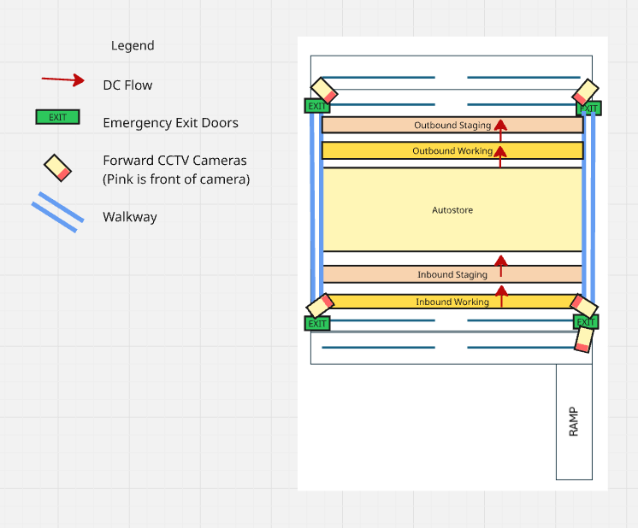
Planning Methodology:
The DC will be an I shape flow. We will be using Auto Store for the storage system. There is a high number of backpacks flowing, and I shape reduces confusion as there is a clear separation between inbound and outbound. Compared to “U shape” which is more error prone due to its compact design and unclear separation between inbound and outbound operations.
There’s no need for a U shape design forward picking is not needed with Auto Store. It’s more scalable due to the simplistic design of a straight through flow, and it’s better suited for automation, e.g. conveyers can be easily integrated due to the predictable path of a straight line.
Emergency exits at each corner allow easy navigation and accessibility from anywhere in the Distribution Center. Even if you don’t know where the emergency exit is, you will run into one as long as you try to exit the DC.
Cameras at each corner to capture traffic into and out from the DC. The emergency exits are vulnerable as they can be used to sneak out of the DC. Hence, each exit has a camera monitoring it’s in and out traffic. The camera outside captures high traffic, as it’s the main entrance and exit for goods, and vehicles arrive there providing valuable information in the case of accidents or theft.
There are no cameras in the Auto Store because it’s surrounded by four walls, compartmentalized by bins, and operated by a robot. There are records in the system when goods are picked or put away.
The pedestrian walkway allows easy access and provides return paths throughout the DC to many different areas. It helps to reduce chances of accidents between pickers and vehicles when handlers are in motion.
FIFO Requirement
Auto Store performs FIFO by using its software to track the timestamps of items stored in each bin and retrieve the oldest stock first. Since bins are stacked vertically, the system may need to move upper bins to access older inventory below, a process known as “digging.”
Storage Height
The maximum height is 14m as the ceiling is 14m. Only the storage area may exceed it unlike working and staging areas. Auto Store is usually 4-6 meters high, so there is no need to worry about its height. However, there is no information on the backpack’s dimensions so we can’t derive the number of bins for the Auto Store
E. Derived Requirements
Number of Dock Doors required
Assumptions:
- Only inbound is needed, as outbound is handled by freight forwarder. Shipping Carton is handed over to Freight Forwarder. Hence, no outbound dock door.
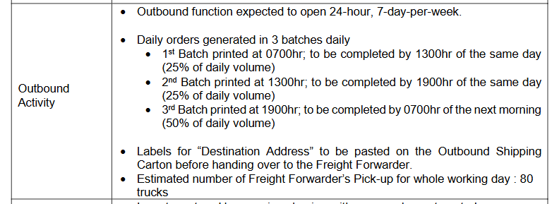
- 1 dock door per 1 handler, for highest efficiency as there is no confusion and bottlenecks
- Highest volume of cartons is 2400, according to TRAVEL PAL’s historical data
- Growth is 10% per annum, length of contract is 5 years
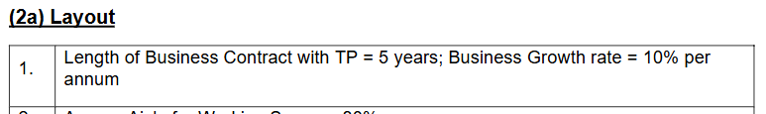

Calculations:
Step 1: Find Highest Volume of Cartons While Accounting For Growth
The Highest Volume of Cartons and Growth must be accounted for, as dock doors cannot be easily expanded or changed.
Derived Formula:
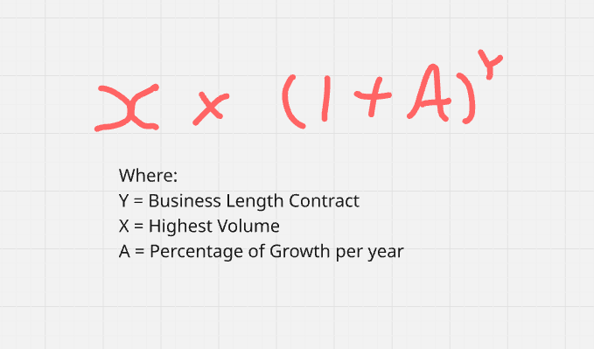
Hence, 2400 * (1+0.1)⁵ = 3866 cartons (rounded up)
Step 2: Find Number of Containers
Derived Formula to Get Containers from Cartons:
Each full pallet has 12 cartons max. Hence, amt of pallets = amt of cartons/12
Each container has 20 pallets max. Hence, amt of containers = amt of pallets/20
Formula for Number of Containers = ((Cartons / 12) / 20)
Using the highest volume of cartons for calculation while accounting for growth will make the container account for growth and peak volume as well.
Using the highest volume of cartons while accounting for growth. Therefore, number of containers is ((3866 / 12) / 20) = 17 (rounded up)

Step 3: Find Time Taken to Unload Each Container
Each container has 20 pallets. Each handler unloads 45 pallets per container every hour, according to the productivity guidelines. Assuming there’s one handler.
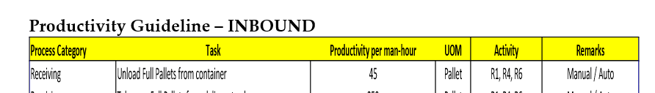
Hence, time taken to finish unloading each container (measured by hours). It’s calculated by pallets per container / pallets unloaded every hour. It takes 20/45 hours, which is roughly 0.44 hours.

Step 4: Calculate number of docks
Derived Formula:
(Inbound Containers * Time Taken to Unload Each Container) / Working Hours Per Day

Containers = 16 (Accounts for growth and peak volume, in step 1 and 2)
Time Taken to Unload Each Container (measured by hours) = 0.44 hours
Working Hours Per Day = 8.5 hours.
(16 * (20/45)) / 8.5 = 1 (rounded up).

In conclusion, the number of docks required is 1 dock accounting for growth and peak volume. Outbound cartons are handed over to freight forwarder so there is no need for outbound dock doors.

Area of Working Space and Staging Space (for both Outbound and
Inbound)
Staging Spaces
Assumptions:
- Pallet dimensions are 1.2m x 1.1m
- Factor for Access Aisle is 60%
- Staging Space handles 30% of shift volume
Calculations:
Step 1: Find Highest Outbound Cartons Volume While Accounting for Growth
The Highest Volume of Cartons and Growth must be accounted for, as space allocations cannot be easily expanded or changed.
Derived Formula:
Inbound Volume Cartons = 2400 (from TRAVEL PAL’s historical data highest inbound volume)
Hence, 2400 * (1+0.1)⁵ = 3866 cartons (rounded up, one piece per carton)

Outbound Volume Cartons = 1865 (from TRAVEL PAL’s historical data)
Hence, 1865 * (1+0.1)⁵ = 3004 cartons (rounded up, one piece per carton)
Step 2: Get amount of pallets at any point of time
Staging spaces expected to hold 30% of Shift volume at any point in time
Each full pallet has 12 cartons max. Hence, amt of pallets = amt of cartons/12. Daily volume is shift volume for inbound as there is only one shift.
Inbound shift pallet volume: 3866 / 12 = 323 (rounded up)
323 is inbound pallet shift volume. Hence, 323 * 0.3 = 97 pallets (rounded up)

16 Outbound Shipping Cartons is equivalent to 1 pallet space
Outbound daily pallet volume: 3004 cartons / 16 = 188 pallets (rounded up)
There are 3 shifts. Hence, each shift handles 188 / 3 = 63 pallets (rounded up)
63 is outbound pallet shift volume. Hence, 63 * 0.3 = 19 pallets (rounded up)

Step 3: Calculate staging area space
The dimension of a pallet is 1.2m x 1.1m. Hence, the area of one pallet: 1.2 * 1.1 = 1.32 m ²
Access Aisle for Staging Space = 60% (QUICK-QUICK LOGISTICS’ Business Assumptions)
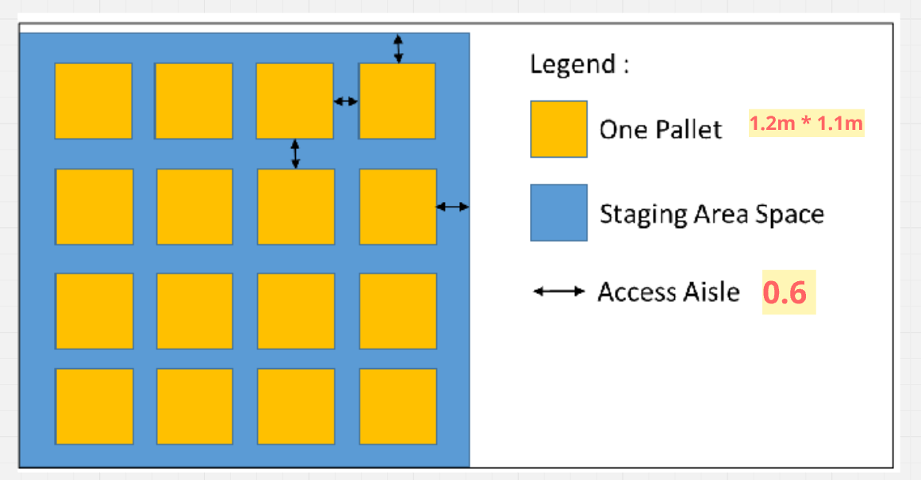

The formula is taken from the course material. It calculates the amount of space for staging area while accounting for aisle access.

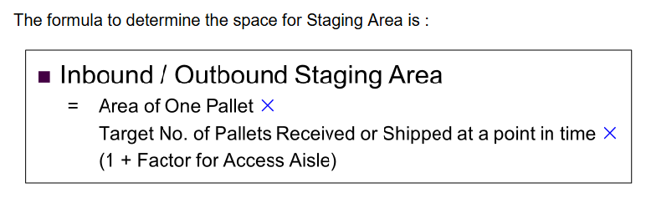

In conclusion,
Inbound Staging Area Space: 1.32 * 97 * (1+0.6) = 205 m² (rounded up)
Outbound Staging Area Space: 1.32 * 19 * (1+0.6) = 53 m² (rounded up)

Working Spaces
Using assumptions, and calculations derived from staging space calculation above, and the following.
Assumptions:
Access Aisle for Working Space = 80%
The dimension of a pallet is 1.2m x 1.1m. Hence, the area of one pallet: 1.2 * 1.1 = 1.32 m ²
Access Aisle for Working Space = 80% (QUICK-QUICK LOGISTICS’ Business Assumptions)
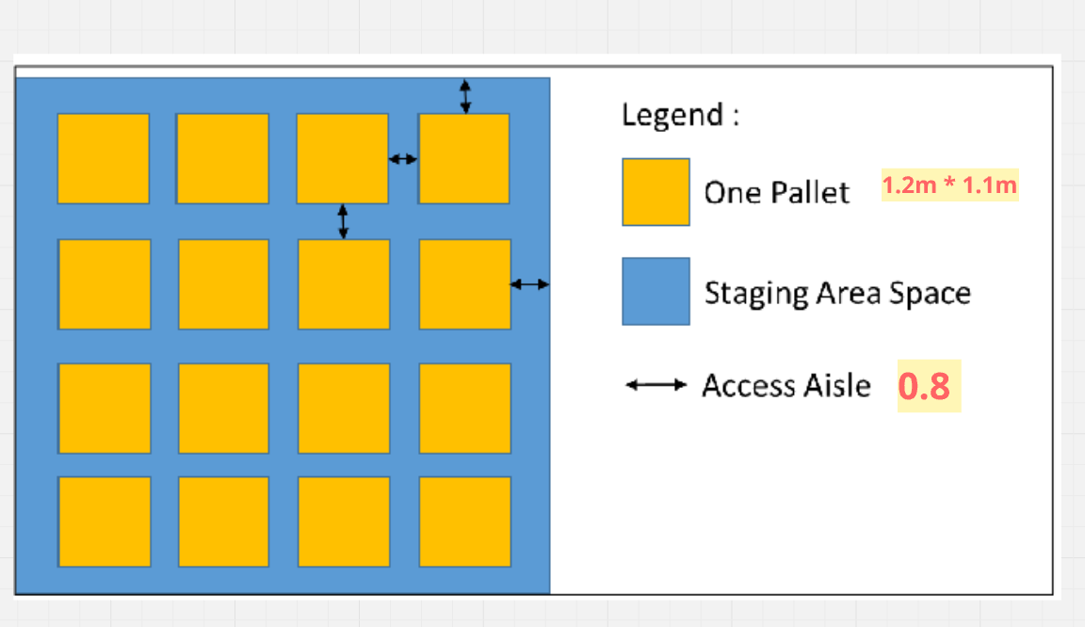

The formula is taken from the course material. It calculates the amount of space for working area while accounting for aisle access.

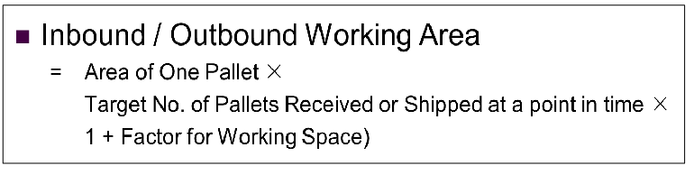

In conclusion,
Inbound Working Area Space: 1.32 * 97 * (1+0.8) = 231 m² (rounded up)
Outbound Working Area Space: 1.32 * 19 * (1+0.8) = 60 m² (rounded up)
Estimated total DC space area
The Distribution Center contains:
- Auto Store Area
- Inbound/Outbound Staging Area
- Inbound/Outbound Working Area
Working and Staging Space area
((231 + 60) + (205 + 53)) * (1+0.25) = 687 m ² (Rounded Up)
Hence, total Area
687 + 10000 = 10687 m ²

F. Pallet-In-Pallet-Out operation

Recommended: Drive-Thru Racking
FIFO is a requirement and there’s low SKUs (30 SKUs), which are well suited and high volume per SKU. Maximizes storage density by removing aisles between racks. Suitable for storing large quantities of the same SKU in lanes. Also, it costs less than VNA.
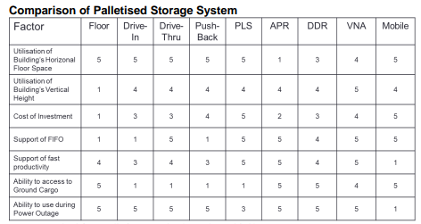

The highest volume of balance is now 4064. In three years' time it will be 4064 * (1+0.1) ³ = 5410 cartons (rounded up). Hence, the number of pallets is derived by cartons divided by inbound cartons per pallet. 5410 / 12 = 451 pallets (rounded up). Pallet locations require 30% of total business pallet volume, which is 451 * 0.3 = 136 pallets (rounded up)
The formula for growth is shown below.
Drive Thru Racking is Tier 5 (max tier), as the maximum height is 14m. The highest point of cargo is only 10m lower than the ceiling max height.
Hence, technical space per pallet is 0.37
Honey combing factor for Drive Thru Racking is 70%
Using the storage Area formula, the standing storage space area is (0.37 / 0.7) * 136 = 72m ²

